RISK ASSESSMENT DETAILS | DEGREE OF RISK | RISK RATING MATRIX
Other assessments which might also be required, ✓ if needed:  - Manual Handling REF  - COSHH REF  - Personal Protective Equipment (PPE) REF  - Noise REF  - Other REF
  Faculty/School/Service | Mathematics
  Team | Sam Pegler & Onno Bokhove/Maths Fluids Laboratory
  Risk Assessment Title | Wetropolis flood demonstrator
  Risk Assessment Log Reference
  Date | 22-01-2020 and 10-05-2021
  Name of Assessors
  Manager Responsible | 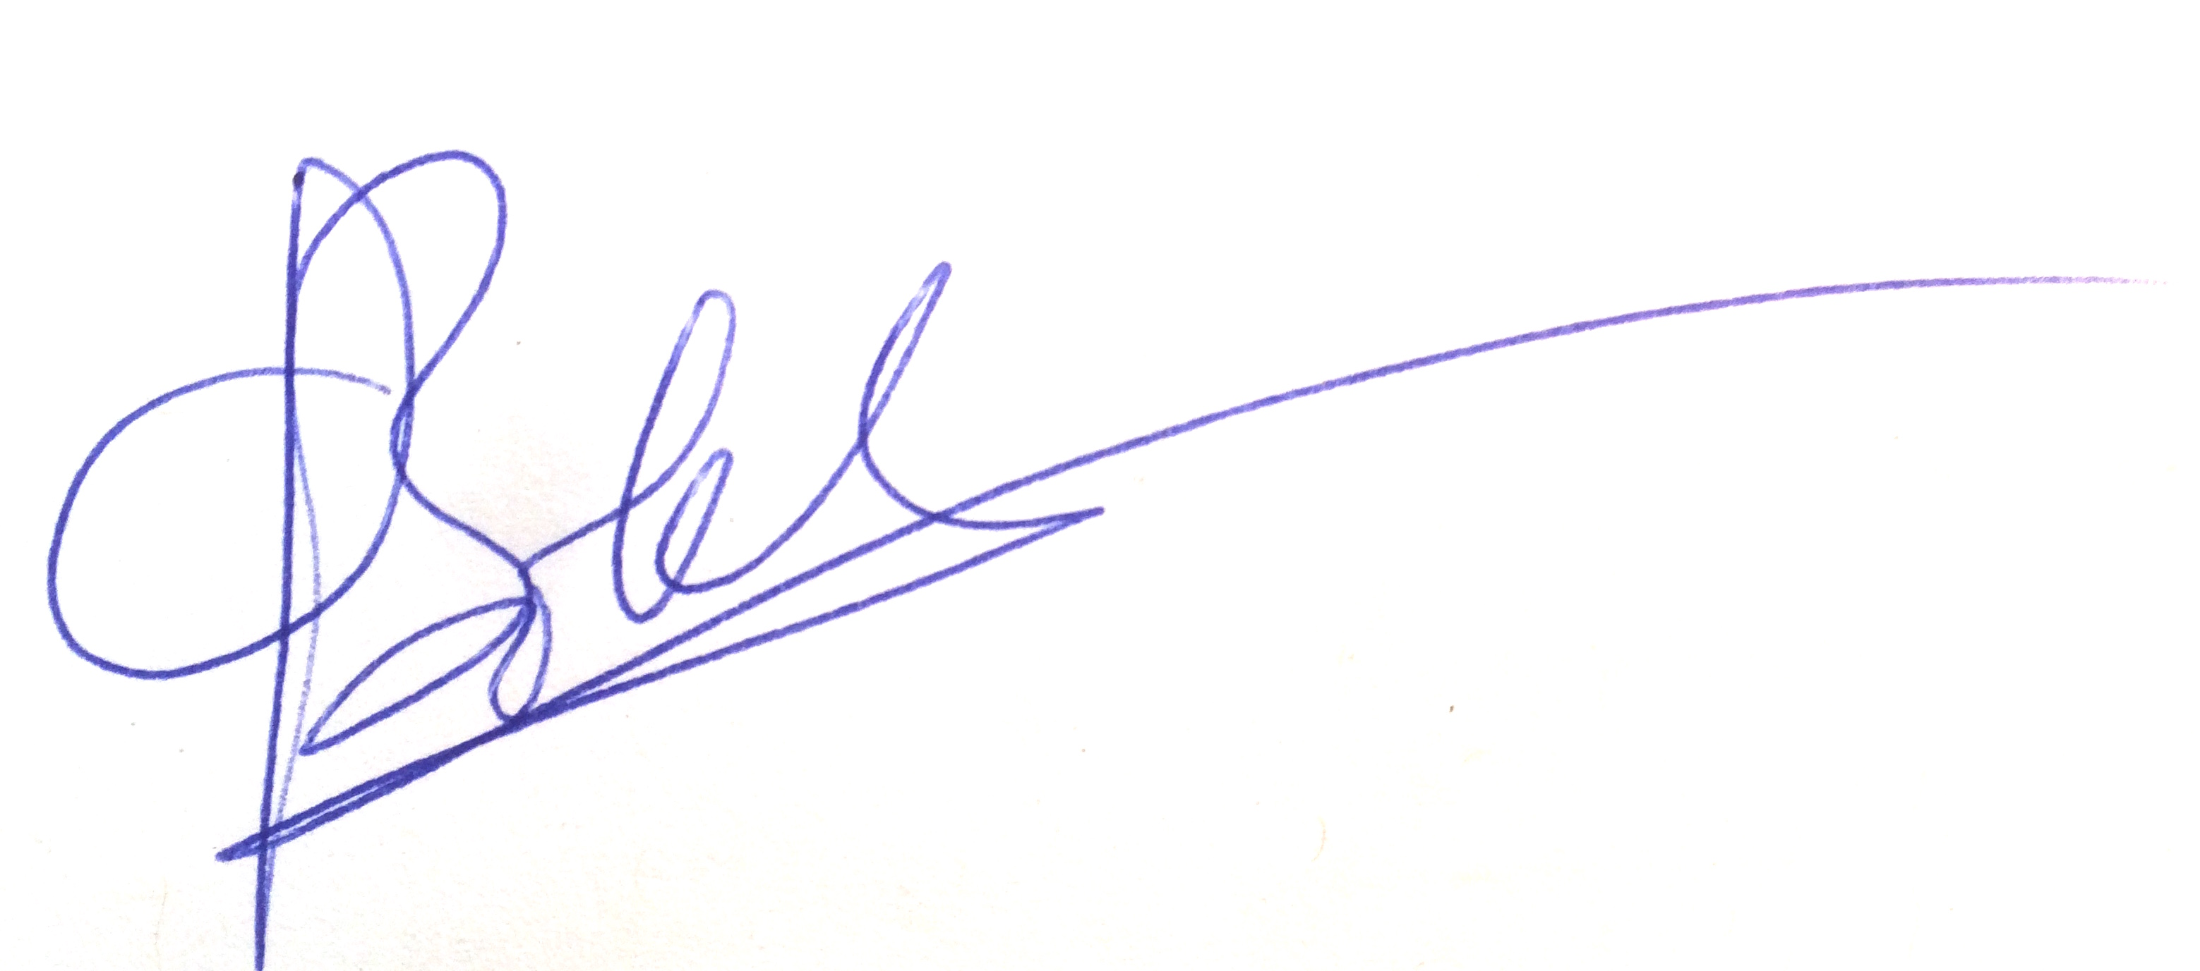
  Location | Chemistry B13
  Details of Activity
  Wetropolis Flood demonstrator (set-up itself plus separate table with electronics): System pumps water along a channel and through other components to simulate flooding events. Set-up involves (~3) buckets of water and a pump that must remain water-submerged.
  https://github.com/obokhove/wetropolis20162020
  https://github.com/obokhove/wetropolis20162020/tree/master/feedback
  for links to YouTube movies and images.
  LIKELIHOOD (L)
  5 | Inevitable
  4 | Highly Likely
  3 | Possible
  2 | Unlikely
  1 | Remote Possibility
   |  | SEVERITY
  LIKELIHOOD |  | 1 | 2 | 3 | 4 | 5
  LIKELIHOOD | 1 | 1 | 2 | 3 | 4 | 5
  LIKELIHOOD | 2 | 2 | 4 | 6 | 8 | 10
  LIKELIHOOD | 3 | 3 | 6 | 9 | 12 | 15
  LIKELIHOOD | 4 | 4 | 8 | 12 | 16 | 20
  LIKELIHOOD | 5 | 5 | 10 | 15 | 20 | 25
 |  | PERSONS AT RISK
  SEVERITY (S)
  5 | Very High -Multiple Deaths
  4 | High - Death, serious injury, permanent disability
  3 | Moderate - RIDDOR over 7 days
  2 | Slight - First Aid treatment X
  1 | Nil - Very Minor

PERSONS AT RISK

Employees X

Students X

Clients

Contractors

Members of the public X

Work Experience students

Other Persons

  REVIEW DATES
  RISK RATING SCORE | ACTION
  1 - 4 | Broadly Acceptable - No action required
  5 - 9 | Moderate - Reduce risks if reasonably practicable
  10 -15 | High Risk - Priority Action to be undertaken
  16 -25 | Unacceptable -Action must be taken IMMEDIATELY

HAZARD AND RELATED ACTIVITIES  e.g. trip, falling objects, fire, explosion, noise, violence etc. | PERSONS  AT RISK  e.g. Employees, Customers, Contractors, Members of the public | POSSIBLE OUTCOME | RISK RATING BEFORE CONTROLS (LxS) | EXISTING CONTROLS  e.g. Guards, Safe Systems of Work, Training, Instruction, Authorised Users, Competent Persons, Personal Protective Equipment (PPE) |  |  | RISK RATING AFTER CURRENT CONTROLS (LxS) | FURTHER CONTROLS REQUIRED? | RISK RATING AFTER ADDITIONAL CONTROLS (LxS)
Electrocution | All | Electrocution resulting in death. | 3x4=12 | - Using water safe rated pond pump.  - All electrical components kept above Wetropolis level and above separate table to avoid electricity and water coming into contact in case of leak.  - Waterproof cabling taped in place to control positions.  - Table and demonstrator to be kept close enough together that one cannot attempt to walk through the region in between, risking the damaging of the equipment and cabling.  - Any extension leads off the ground  - 16V  - PAT testing/visual inspection required |  |  | 2x4=8 | No | RCD: Residual Current Device  is added.  A residual-current device (RCD), residual-current circuit breaker (RCCB), or ground-fault circuit interrupter (GFCI) is a device that quickly breaks an electrical circuit to prevent serious harm from an ongoing electric shock. ... RCDs are testable and resettable devices.
Fire (aquarium pumps burning out when not under water) | All | Fire/Burning/Electrocution | 3x2=6 | - The pumps have in-built safety features; they will fail if out of water.  - Ensure that the pump is fully under water to depth in the water bucket.  - System only to be operated when user is in the lab.  - The bucket is fixed in place to the equipment to ensure it cannot fall or be kicker over  - Ability to turn off quickly if required  -IP46 to IP47 (they are acquarium pumps) |  |  | 2x2=4 | No
Slipping from spilled water | All | Injury | 2x2=4 | Wipe up spilled water immediately; paper towels and a mop available. |  |  | 2x1=2 | No
Trip from wires between table and electronics | All | Injury | 2x2=4 | Keep Wetropolis close to the table to avoid walking in the gap. Position any connections away from the floor in such a way as to avoid trip hazard. |  |  | 2x1=2 | No
Clean-up | All | Illness and poor experiments | 2x1=2 | If the equipment is not to be used for a while, i.e. within 24-36hrs, then it should be emptied and left dry (from a legionnaire's perspective and from a growth-viscosity perspective). Is/was already normal practice. |  |  | 2x1=2 | No
Lone working (during Covid-19) | 1 | Alone during injury | 2x2=4 | Per the SOP:  Only 1 person in the lab per day, except for occasional assistance with transport.  All lab surfaces need to be disinfected using sanitary paper towels provided. The towels need to be disposed of in a special sanitary bin, disposed via general waste.  When working alone, arrange a buddy. Let the buddy know when you plan to work in the lab and for what times. Send a quick message to them at the start and end of each of your working sessions and every 2-hour interval.  In case buddy not on site and escalation required, contact site manager Ian Blakely I.J.Blakeley@leeds.ac.uk  +44(0)113 343 6472  Leave the door propped open.  Out of hours working is currently not allowed unless by special request via the HoS and H&S (normal working hours in chemistry currently allow work between 7am and 8pm)  There is a telephone  This can be used to call emergency services or security. Be aware that there is a porters’ office across the corridor that is usually occupied. |  |  | Lone working (during Covid-19) | no | Alone during injury
Waste stream cleaned | All | - | - | There is no waste stream; clean water is used and tanks are emptied directly or for Wetropolis within circa 24-36hrs, so this is covered under clean-up. |  |  | - | No
MANAGEMENT AGREED  ADDITIONAL CONTROL MEASURES REQUIRED |  |  |  |  | ACTIONED BY |  |  |  |  | ACTION COMPLETE
 |  |  |  |  | POSITION | NAME |  |  | DATE | MANAGER SIG |  | DATE

COMMUNICATION OF RISK ASSESSMENT FINDINGS TO STAFF
REFERENCE OF FORMAL COMMUNICATION TO STAFF | METHOD | YES | DATE | COMMENTS
REFERENCE OF FORMAL COMMUNICATION TO STAFF | Copy of risk assessment issued to staff
REFERENCE OF FORMAL COMMUNICATION TO STAFF | Controls covered in team procedure issued to staff
REFERENCE OF FORMAL COMMUNICATION TO STAFF | Staff Handbook issued to staff
REFERENCE OF FORMAL COMMUNICATION TO STAFF | Other -
ADDITIONAL METHODS OF COMMUNICATION | Induction
ADDITIONAL METHODS OF COMMUNICATION | Toolbox Talk
ADDITIONAL METHODS OF COMMUNICATION | Team Meeting
ADDITIONAL METHODS OF COMMUNICATION | E-mail circulation
ADDITIONAL METHODS OF COMMUNICATION | Other -

COMMENTS AND INFORMATION

(Use this section to record any dynamic risk assessment comments and information)

Do additional controls adequately lower high risk activities to an acceptable level? | YES / NO  If NO explain in comments box above | SIGNATURE OF MANAGER  "The risks identified in this assessment are controlled so far as is reasonably practicable"
 | YES / NO  If NO explain in comments box above | Signature: | Date:

DATE OF REASSESSMENT  (Every two years minimum) | ARE THERE ANY CHANGES TO THE ACTIVITY SINCE THE LAST ASSESSMENT? | SIGNATURE OF MANAGER

LOCATION OF CURRENT SIGNED RISK ASSESSMENT

RISK ASSESSMENT LOG
Directorate: |  |  |  |  |  | Area:
Section/Team | Risk Assessment Title | Version No. | Risk Assessment Category | Code  /Location | Risk Assessor | Manager responsible for signing off risk assessment | Date assessment signed off | Review Due | Review Date | Outstanding Controls/Actions  Yes/No | Comments

